

**Mobile Shop**

|  |  |  |
| --- | --- | --- |
| **Supervisor:** | *LÊ THANH NHÂN* | |
| **Semester:** | *II* | |
| **Batch No:** | *T1.2011.M0* | |
| **Group No:** | *01* | |
| **Order:** | **Full name** | **Roll No.** |
| *1.* | *Đỗ Huy Hoàng* | *Student1288223* |
| *2.* | *Đỗ Thành Nam* | *Student1286087* |
| *3.* | *Huỳnh Thị Phương Thanh* | *Student1279108* |
| *4.* | *Huỳnh Minh Phát* | *Student1288468* |

***Month****: 09* ***Year****: 2021*



This is to certify that

|  |  |
| --- | --- |
| **Mr.** | **Đỗ Huy Hoàng** |
| **Mr.** | **Đỗ Thành Nam** |
| **Ms.** | **Huỳnh Thị Phương Thanh** |
| **Ms.** | **Huỳnh Minh Phát** |

Have successfully Designed & Developed

|  |  |  |
| --- | --- | --- |
|  |  |  |
| **Mobile Shop** | | |

Submitted by:

|  |
| --- |
| **Mr. LE THANH NHAN** |

Date of Issue:

|  |  |
| --- | --- |
|  |  |

Authorized Signature:

|  |  |
| --- | --- |
|  |  |

Content

Content

Acknowledge

Synposis

Review 1 ………………………………………………………………………..(1)

Review 2 ………………………………………………………………………..(7)

Review 3 ………………………………………………………………………..(26)

Testting Document ……………………………………………………………...(36)

Final Checklist ………………………………………………………………….(37)

Tasksheet ………………………………………………………………………..(39)

**Acknowledge**

As we understand that the Project is a step-by- step learning environment that closely simulates the class-room and Lab based learning environment into actual implementation. It is a projectimplementation at your fingertips!! An electronic, live juncture on the machine that allows you to.

* Practice step by step i.e. laddered approach.
* Build a larger more robust application.
* Usage of certain utilities in applications designed by user.
* Single program to unified code leading to a complete application.
* Learn implementation of concepts in a phased manner.
* Enhance skills and add value.
* Work on real life projects.
* Give a real life scenario and help to create applications more complicated and useful.
* Mentoring through email support.

We would like to send a great thank to our professor, Mr Le Thanh Nhan and others student for the addorable supports during the time in project.

Beside serveral mistakes we had made in the project, we hope to have more oppotunities to widen our knownledge in web developing world.

We also thank you so much for your infomation and the “demo” project from India APTECH to help us get more reality experience in this project. Since we have gained more experience from this project, we will not stop learning any thing as much as we can to be more successful in the future.

Your Sincerely,

Team Group 01.

**Synposis**

The Objective of this program we aim is to give a sample project to work on real life projects. These applications help us build a larger more robust application.

The objective is not to teach us front-end or back-end technology but to provide us with a real life scenario and help us create basic applications using the tools.

Hence, we can revise the chapters before we start with the project.

This project is meant for students like us who have completed the module of Semester II, as well as special subjects those are Java and PHP. These programs should be done in the Lab sessions with assistance of the faculty if required.

The website (in this project) is a world that brings everything about the potteries and crockeries into your experience.

It is very essential for us that will have a clear understanding of the subject. We think we should go through the project and solve the assignments as per requirements given.

Review 1

|  |
| --- |
| Problem Definition |

Mobile Shop company, are is one of the famous units specializing in providing electronic devices (phones, computers, accessories). The company has many stores nationwide to provide products to people. Our company has products not only in the domestic market but also in the international market. One solution where we have a website of our own, which will store information about the products of a company with a lot of categories.

Based on the need stated in the Project Overall, we design an application that will provide the key features and functionalities as the followings:

* Provide function for member register.
* Provide information of the product to customers and members.
* Provide shopping cart function so customers and members can order products.
* The member can take their privacy through Member Control Panel (MCP)
* Receive comments from customers and members to improve service quality as well as product quality.

An Admin Control Panel (ACP) that support about management system:

* Administrators the ability to add, update product information quickly and accurately.
* Administrators the ability to manage members and their feedback.
* Administrators the ability to manage delivery progress belong to orders.

Administrators the ability report statistics.

* The Role of User and Admin:

1. User:
   * Can register as a member and manage personal account.
   * Can view and buy products.
   * Can give feedback, comment, rate about products.
   * Can view their orders.
2. Administrator
   * Can add / edit / deactivate products and categories.
   * Can view customer’s information or deactivate an account.
   * Can reply the feedback or comment.
   * Can view all orders and approve orders.
   * Can view report statistics.

|  |
| --- |
| Customer Requirements Specifications |

|  |
| --- |
| **User:** |
| **input:** |
| * Member registration information. * View product’s information. * Order selected products. * Feedback about products |
| **Process:** |
| * Search products from database by categories, by product types. * Process customer registration information. * Process product’s feedback. * Process customer orders. |
| **Output:** |
| * Notification of successful registration / failure. * Product information. * Notification of successful making order order. |

|  |
| --- |
| **Webmaster:** |
| **input:** |
| * Administrator login information . * Product and category information to add / edit / delete. * Member information to be search / delete. * Order information to be search / approve. |
| **Process:** |
| * Add / edit / delete products. * View information of all members. * Change member account’s status. * View all orders. |
| **Output:** |
| * Notification to add / edit / delete products success / failure. * Notification to change member account’s status. |

**Hardware / software requirement**

|  |  |  |
| --- | --- | --- |
| **Sr.** | **Item** | **Description** |
| 1. | Operating system | Windows 7, 8, or higher |
| 2. | Hardware | CPU Cores or better with 2 Gigabytes of RAM or better |
| 3. | Web Browser | Version in later of: Edge, Firefox, Chrome, etc… |
| 4. | Fonts | Standard font Unicode: Arial, Tahoma, Lucida Console, Times New Roman, etc… |
| 5. | Other requirement | NodeJS, Git, XAMPP 7.3 or later | A working internet connection. |

REVIEW 2

|  |
| --- |
| Data flow diagram |

1. Entity Relationship Diagram

## ENTITY REATION DIAGRAM PROPERTIES

1. Table design

|  |  |  |  |  |  |
| --- | --- | --- | --- | --- | --- |
| **User** | | | | | |
| **Serial** | **Fields** | **Data type** | **Keys** | **Constrains** | **Description** |
| 1 | id | int(11) | Primary key | UNSIGNED, Not null | Sequence number |
| 2 | name | varchar(191) |  | Not null | User name |
| 3 | email | varchar(191) |  | Not null | User email |
| 4 | password | varchar(191) |  | Not null | User password |
| 5 | remember_token | varchar(100) |  | Null | User remember |
| 6 | is_admin | tinyint(4) |  | Not Null,  default(0) | Is admin |
| 7 | created_at | timestamp |  | Null | User creation time |
| 8 | updated_at | timestamp |  | Null | User creation time |
| 9 | deleted_at | timestamp |  | Null | User delete time |

|  |  |  |  |  |  |
| --- | --- | --- | --- | --- | --- |
| **Role_user** | | | | | |
| **Serial** | **Fields** | **Data type** | **Keys** | **Constrains** | **Description** |
| 1 | id | int(11) | Primary key | UNSIGNED, Not null | Sequence number |
| 2 | user_id | int(11) | Foreign key | UNSIGNED, Not null | Id user |
| 3 | role_id | int(11) | Foreign key | UNSIGNED, Not null | Id role |
| 7 | updated_at | timestamp |  | Null | Role user creation time |
| 8 | deleted_at | timestamp |  | Null | Role user creation time |

|  |  |  |  |  |  |
| --- | --- | --- | --- | --- | --- |
| **Roles** | | | | | |
| **Serial** | **Fields** | **Data type** | **Keys** | **Constrains** | **Description** |
| 1 | id | int(11) | Primary key | UNSIGNED, Not null | Sequence number |
| 2 | name | varchar(191) |  | Not null | Roles identification |
| 3 | display_name | varchar(191) |  | Not null | Role description |
| 4 | created_at | timestamp |  | Null | Roles creation time |
| 5 | updated_at | timestamp |  | Null | Roles creation time |

|  |  |  |  |  |  |
| --- | --- | --- | --- | --- | --- |
| **Permissions** | | | | | |
| **Serial** | **Fields** | **Data type** | **Keys** | **Constrains** | **Description** |
| 1 | id | int(11) | Primary key | UNSIGNED, Not null | Sequence number |
| 2 | name | varchar(191) |  | Not null | Permission name |
| 3 | display_name | varchar(191) |  | Not null | Permission description |
| 4 | Parent_id | varchar(191) | Foreign key | Not null | Id permission |
| 5 | key_code | varchar(191) |  | Not null | Product identification |
| 6 | created_at | timestamp |  | Null | Roles creation time |
| 7 | updated_at | timestamp |  | Null | Roles creation time |

|  |  |  |  |  |  |
| --- | --- | --- | --- | --- | --- |
| **Permission_role** | | | | | |
| **Serial** | **Fields** | **Data type** | **Keys** | **Constrains** | **Description** |
| 1 | id | int(11) | Primary key | UNSIGNED, Not null | Sequence number |
| 2 | role_id | int(11) |  | UNSIGNED, Not null | Id Role |
| 3 | permission_id | int(11) |  | UNSIGNED, Not null | Id permission |
| 4 | created_at | timestamp |  | Null | Roles creation time |
| 5 | updated_at | timestamp |  | Null | Roles creation time |

|  |  |  |  |  |  |
| --- | --- | --- | --- | --- | --- |
| **Category** | | | | | |
| **Serial** | **Fields** | **Data type** | **Keys** | **Constrains** | **Description** |
| 1 | id | int(11) | Primary key | UNSIGNED, Not null | Sequence number |
| 2 | name | varchar(191) |  | Not null | Category name |
| 3 | id_parent | int(11) |  | Not null | Id parent |
| 5 | created_at | timestamp |  | Null | Roles creation time |
| 6 | updated_at | timestamp |  | Null | Roles creation time |
| 7 | deleted_at | timestamp |  | Null | Roles delete time |

|  |  |  |  |  |  |
| --- | --- | --- | --- | --- | --- |
| **Product** | | | | | |
| **Serial** | **Fields** | **Data type** | **Keys** | **Constrains** | **Description** |
| 1 | id | int(11) | Primary key | UNSIGNED, Not null | Sequence number |
| 2 | name | varchar(255) |  | Not null | Product name |
| 3 | price | varchar(255) |  | Not null | Product price |
| 4 | feature_img_path | varchar(255) |  | Not null | Photo address |
| 5 | feature_img_name | varchar(255) |  | Not null | Photo name |
| 6 | category_id | int(11) |  | UNSIGNED, Not null | Id category |
| 7 | content | text |  |  | Content |
| 8 | created_at | timestamp |  | Null | Roles creation time |
| 9 | updated_at | timestamp |  | Null | Roles creation time |
| 10 | deleted_at | timestamp |  | Null | Roles delete time |

|  |  |  |  |  |  |
| --- | --- | --- | --- | --- | --- |
| **Product_images** | | | | | |
| **Serial** | **Fields** | **Data type** | **Keys** | **Constrains** | **Description** |
| 1 | id | int(11) | Primary key | UNSIGNED, Not null | Sequence number |
| 2 | img_path | varchar(255) |  | Null | Photo Address |
| 3 | img_name | varchar(255) |  | Not null | Photo name |
| 4 | product_id | int(11) |  | Not null | Id product |
| 6 | created_at | timestamp |  | Null | Roles creation time |
| 7 | updated_at | timestamp |  | Null | Roles creation time |

|  |  |  |  |  |  |
| --- | --- | --- | --- | --- | --- |
| **Customer** | | | | | |
| **Serial** | **Fields** | **Data type** | **Keys** | **Constrains** | **Description** |
| 1 | id | int(11) | Primary key | UNSIGNED, Not null | Sequence number |
| 2 | name | varchar(191) |  | Null | Customer name |
| 3 | phone | varchar(191) |  | Null | Phone number |
| 4 | gender | varchar(191) |  | Null | Gender |
| 5 | birthday | date |  | Null | Customer name |
| 6 | user_id | int(11) |  | UNSIGNED, Not null | Id user |
| 7 | address | int(11) |  | Null | Address personal |
| 8 | created_at | timestamp |  | Null | Roles creation time |
| 9 | updated_at | timestamp |  | Null | Roles update time |
| 10 | deleted_at | timestamp |  | Null | Roles delete time |

|  |  |  |  |  |  |
| --- | --- | --- | --- | --- | --- |
| **Order** | | | | | |
| **Serial** | **Fields** | **Data type** | **Keys** | **Constrains** | **Description** |
| 1 | id | int(11) | Primary key | UNSIGNED, Not null | Sequence number |
| 2 | customer_id | int(11) |  | Not null | Id Cútomer |
| 3 | status | varchar(255) |  | Not null | Status Order |
| 4 | created_at | timestamp |  | Null | Roles creation time |
| 5 | updated_at | timestamp |  | Null | Roles update time |

|  |  |  |  |  |  |
| --- | --- | --- | --- | --- | --- |
| **Order_item** | | | | | |
| **Serial** | **Fields** | **Data type** | **Keys** | **Constrains** | **Description** |
| 1 | id | int(11) | Primary key | UNSIGNED, Not null | Sequence number |
| 2 | order_id | int(11) |  | UNSIGNED, Not null | Id order |
| 3 | product_id | int(11) |  | UNSIGNED, Not null | Id product |
| 4 | quantity | int(11) |  | Not null | Quantity |
| 5 | created_at | timestamp |  | Null | Roles creation time |
| 6 | updated_at | timestamp |  | Null | Roles update time |

1. Relationship Diagram

|  |
| --- |
| StiteMap |

1. **Admin**

1. **User**

REVIEW 3

|  |
| --- |
| Screen shots |

1. **Homepage:**

**1. Header**

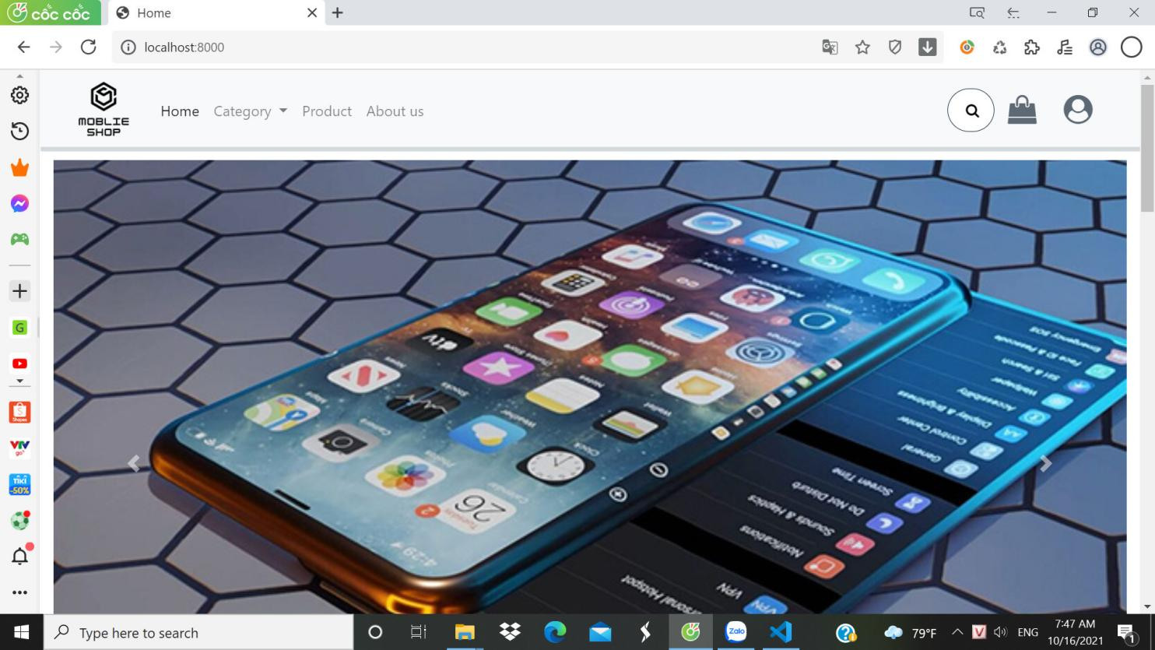

**2.Content**

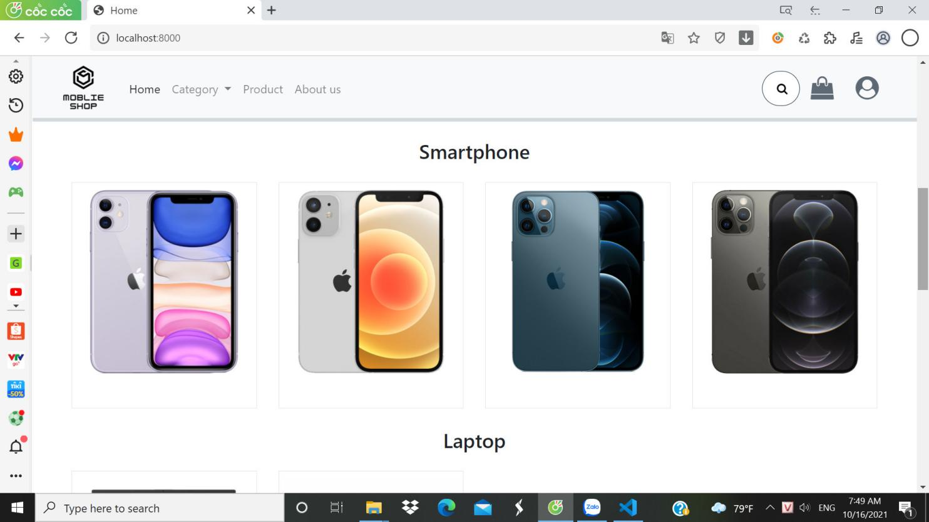

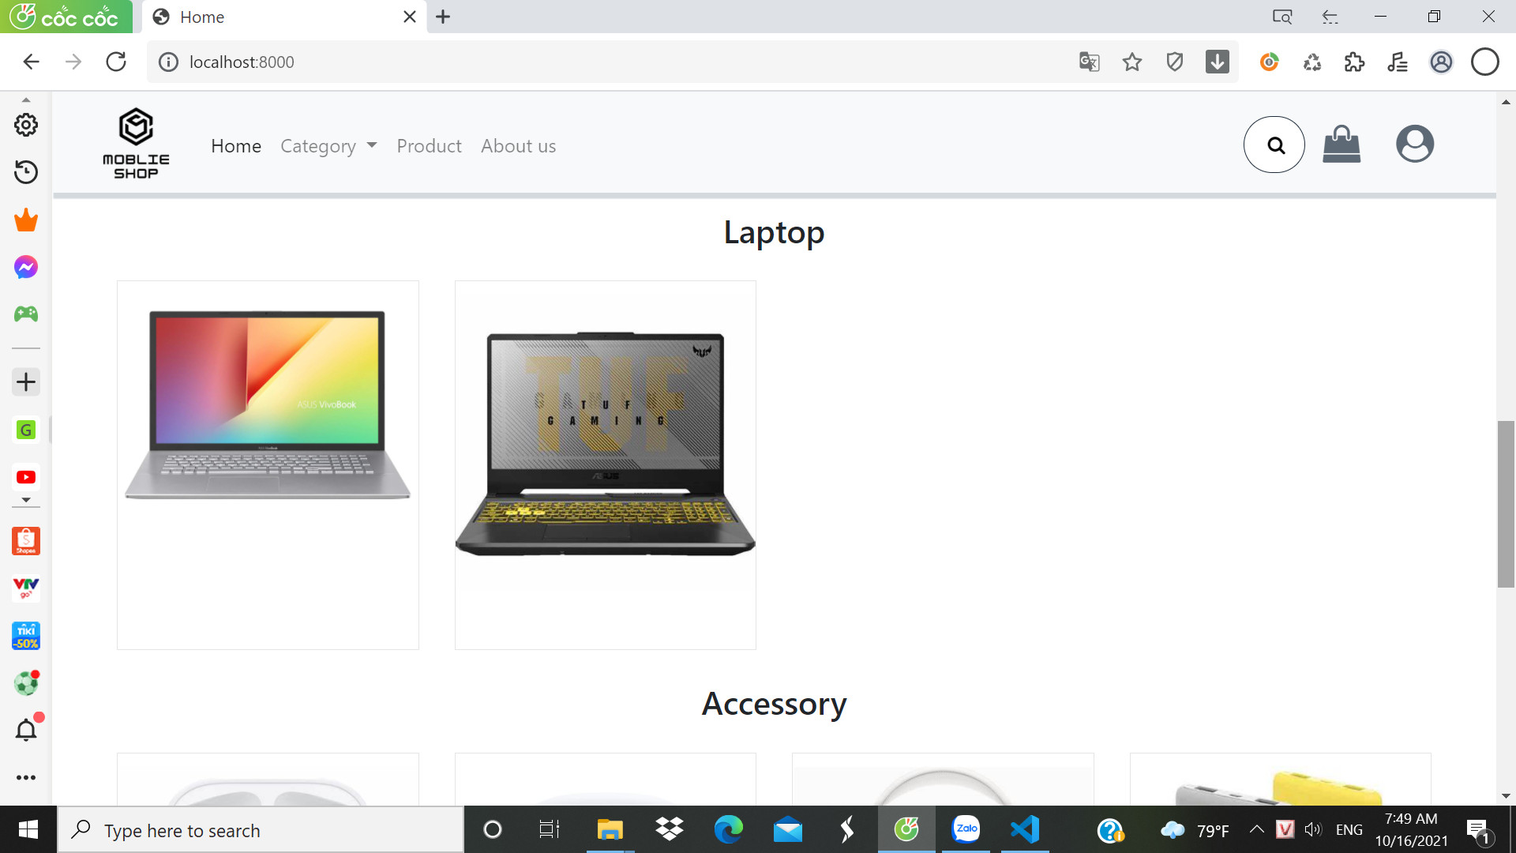



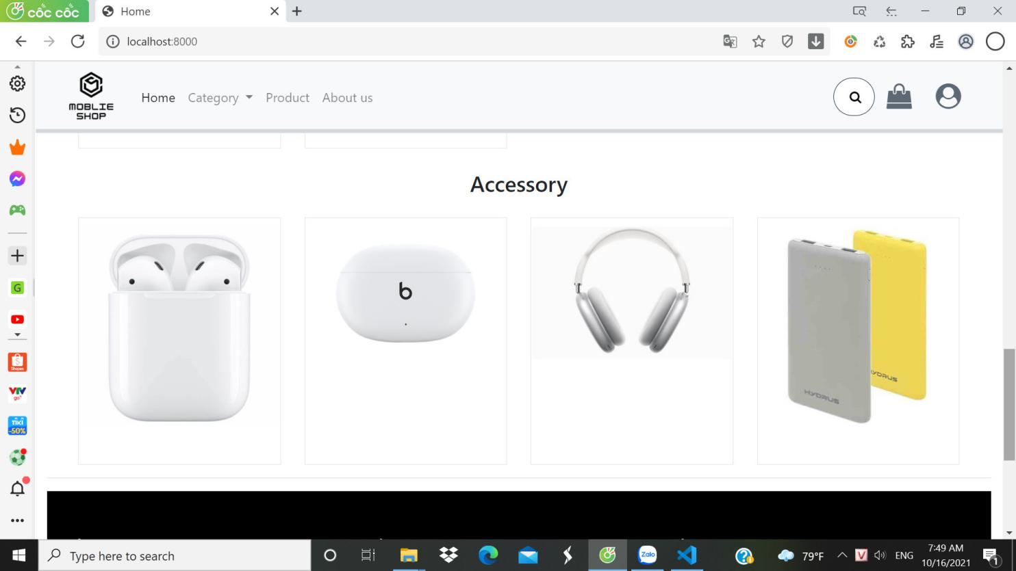

**3.Footer**

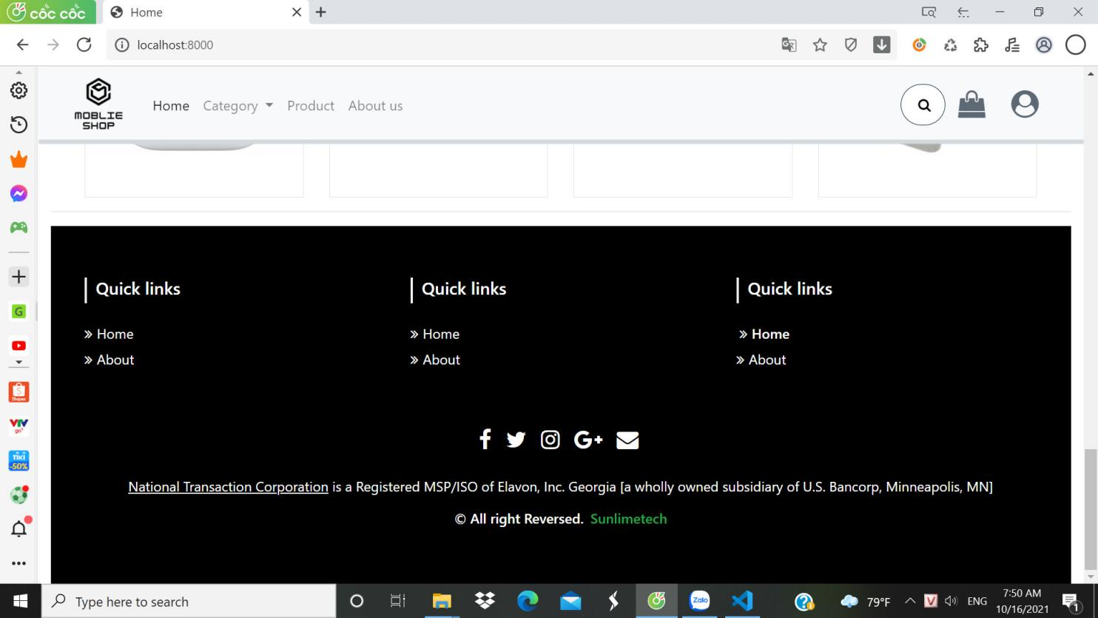

**Description :** The basic image depicts the 4 permanent sections in the Products page, used to view products and place orders.

**From :** Open from the product button on the title bar

**To :** Home, about us, login, shopping cart.

1. **Product**

**Description :** The basic image depicts 3 fixed parts in the HomePage page, used to view products, login and go to another page.

**From :** Open from the home button on the title bar

**To :** Product, about us, login, shopping cart.

1. **Shopping cart**

**Description :** Basic description of the products added to the store.

**From :** The page is opened from the cart icon in the title bar.

**To :** Product, about us, login, home.

1. **Login**

**Description :** The basic image depicts the form for login.

**From :** The page is opened from the user icon in the title bar.

**To :** Home, register.

1. **Register**

**Description :** The basic image depicts the form for login.

**From :** The page is opened from the words Register a new member in the login form.

**To :** Home, Login

1. **Profile**

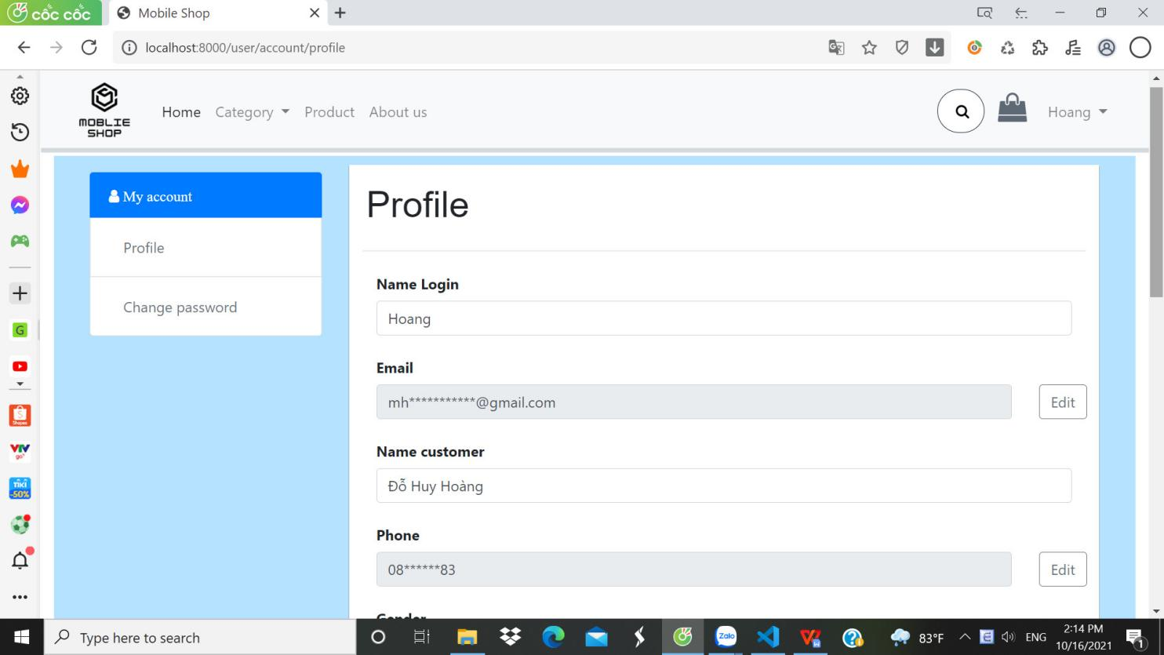

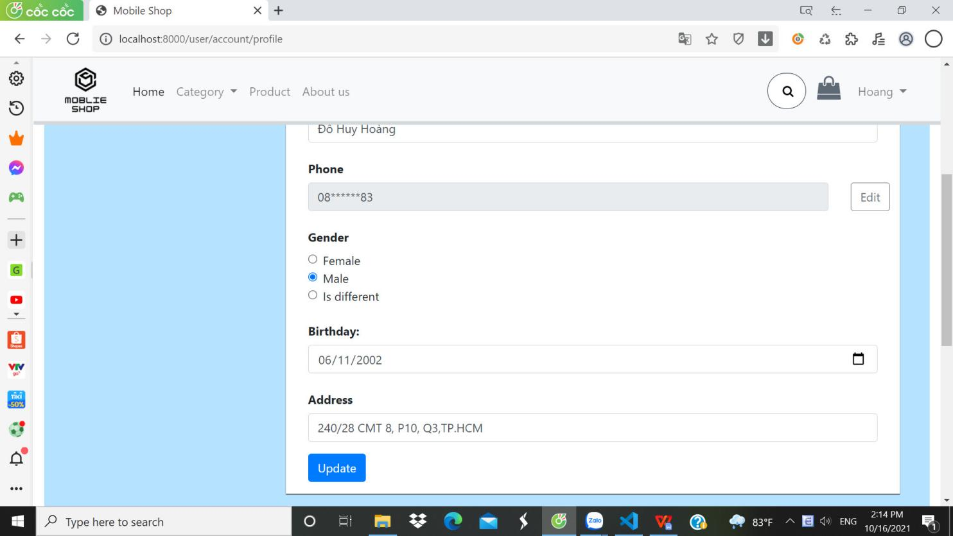

**Description :** The basic image describes the customer information page.

**From :** When successfully logged in, your name will appear on the title bar after the cart icon, when clicking on the name will drop down many lines, you click on the profile line.

**To :** Product, about us, home, shopping cart

1. **Admin**

**Description :** The basic image describes the admin's management page.

**From :** When successfully logged in, your name will appear on the title bar after the cart icon, when clicking on the name will drop down many lines, if you are admin, the admin line will appear and you click on it.

**To :** All management sections of the administrator.

|  |
| --- |
| Testing documnet |

|  |  |  |
| --- | --- | --- |
| **Sr.No** | **Features Tested** | **Remarks** |
| 1 |  |  |
| 2 |  |  |
| 3 |  |  |
| 4 |  |  |
| 5 |  |  |
| 6 |  |  |
| 7 |  |  |
| 8 |  |  |
| 9 |  |  |
| 10 |  |  |
| 11 |  |  |
| 12 |  |  |
| 13 |  |  |
| 14 |  |  |
| 15 |  |  |

|  |
| --- |
| Final checklist |

|  |  |  |
| --- | --- | --- |
| **Sr.No** | **Aspected Tested** | **Suggestion/**  **Remarks** |
| 1 | Are all the users able to view the images and links? |  |
| 2 | Have all the views, modules and controllers been properly integrated and is the site function as a single page application? |  |
| 3 | Are the GUI content devoid of spelling mistakes? |  |
| 4 | Is the application user-friendly? |  |
| 5 | Is the Website launching correctly in all popular browsers? |  |
| 6 | Are all the forms validated with proper criteria? |  |
| 7 | Do all text links lead to the appropriate website? |  |
| 8 | Do all image links lead to the appropriate website? |  |
| 9 | Are all the images and links clearly visible on the page? |  |
| 10 | Does the Web page work properly in all the tested browsers? |  |
| 11 | Does the Web page take too long to be loaded fully? |  |
| 12 | Is the navigation sequences correct through all the Web pages on the site? |  |
| 13 | Is the JavaScript code working as expected in all click events? |  |

|  |  |  |  |  |  |  |  |  |
| --- | --- | --- | --- | --- | --- | --- | --- | --- |
| **No** | **Member** | **Contents** | | **Table Name** | **Activity Plan** | **Date of Preparation of Activity Plan** | | |
| **Planed Start Date** | **Actual Start Date** | **Actual Days** | **Status** |
| 1 | **Đỗ Huy Hoàng** | Admin | *Customer Management, Account List Management,Manager Roler* | User, Role_user, Roler | 28/9/2021 | 29/9/2021 | 5 | OK |
| 2 |  |  |  |  |
| 3 | Customer | *Register* | 28/9/2021 | 29/9/2021 | 5 | OK |
| 4 | *Personal Account Management* | 28/9/2021 | 29/9/2021 | 5 | OK |
|  |  |  |  |  |  |  |  |  |
| 1 | **Đỗ Thành Nam** | Admin | *Category Management, Customer Information Management* | Category, Customer, Permission_role | 28/9/2021 | 29/9/2021 | 5 | OK |
| 2 |  |  |  |  |
| 3 | *Personal Information Management* |  |  | 5 | OK |
| 4 | User | *View Category* |  |  | 5 | OK |
|  |  |  |  |  |  |  |  |  |
| 1 | **Huỳnh Thị Phương Thanh** | Admin | *Order Management* | Order Order_Items | 28/9/2021 | 29/9/2021 | 5 | OK |
| 2 |  |  |  |  |
| 3 | User | *Add Order* | 28/9/2021 | 29/9/2021 | 5 | OK |
| 4 | *Personal Order Management* | 28/9/2021 | 29/9/2021 | 5 | OK |
|  |  |  |  |  |  |  |  |  |
| 1 | **Huỳnh Minh Phát** | Admin | *Product Management, Manager Permission* | Product, Product_image, Permission | 28/9/2021 | 29/9/2021 | 5 | OK |
| 2 |  |  |  |  |
| 3 | User |  |  |  |  |
| 4 | *View Product* | 28/9/2021 | 29/9/2021 | 5 | OK |